Math 327 – Chapter 8 Homework

1. In a regression analysis of on-the-job head injuries of warehouse laborers caused by falling objects, $Y$ is a measure of severity of the injury, $X_{1}$ is an index reflecting both the weight of the object and the distance it fell, and $X_{2}$ and $X_{3}$ are indicator variables for nature of head protection worn at the time of the accident, coded as follows:

Type of Protection $X_{2}$ $X_{3}$

-----------------------------------------------

Hard hat 1 0

Bump cap 0 1

None 0 0

The response function to be used in the study is $E\left\{Y\right\}=β_{0}+β_{1}X_{1}+β_{2}X_{2}+β_{3}X_{3}$.

1. [6 pts] Write the response function for each of the three protection categories.

Hard Hat: $E\left\{Y\right\}=β_{0}+β_{1}X_{1}+β_{2}$

Bump cap: $E\left\{Y\right\}=β_{0}+β_{1}X_{1}+β_{3}$

None: $E\left\{Y\right\}=β_{0}+β_{1}X_{1}$

1. [2 pts] What is the interpretation of ?

β0 represents the y-intercept when no protective headwear is worn (when X2 and X3 are 0). When X2 and X3 are not 0, it represents the mean of the reference group (so when no protective headwear is worn).

1. [2 pts] What is the interpretation of ?

*β1 represents how much higher or lower the response function (injury severity) will be per unit increase of $X_{1}$ (index of height and weight of falling object) when the other categories are held constant.*

1. [2 pts] What is the interpretation of ?

*β2 represents the change in mean response E{Y} (injury severity) when a hard hat is worn, and weight/height of the object is held constant. Measures the differential effects of the qualitative variable classes on the magnitude of the response function for any given value of X1, compared with the class for which* X2 = X3 = 0.

1. [2 pts] What is the interpretation of ?

*β3 represents the change in mean response E{Y} (injury severity) when a bump hat is worn when weight/height of the object is held constant. Measures the differential effects of the qualitative variable classes on the magnitude of the response function for any given value of X1, compared with the class for which* X2 = X3 = 0.

1. [2 pts] How would you test whether the expected severity of injury is the same when wearing a hard hat vs. when wearing a bump cap? Write the null and alternative hypotheses. Hint: The answer for each hypothesis is an expression involving more than one of the parameters.

To test whether the expected severity of injury is the same when wearing a hard hat vs when wearing a bump cap would involve conducting a test described on page 268 of the book under the header “Other Tests”. The procedure would be to fit the full model (7.30) and then the reduced model (7.32). Then you would use the general F\* test statistic (2.70). The test would involve the alternatives H0: = and Ha: ≠ .

1. 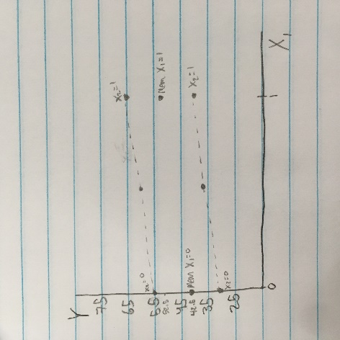[4 pts] Plot these data using the axes at right, connecting points with a line segment (I did dotted line) for level of $X_{2}$. Include the scale on each axis.

$X_{1}$ $X_{2}$ $Y$

--------------------------

0 0 30

1 0 40

0 1 55

1 1 65

[2 pts] Based on the data above, what can you say about $β_{3}$ in the model, $Y=β_{0}+β_{1}X_{1}+β_{2}X_{2}+β_{3}X_{1}X_{2}?$  
 Circle one.

$β_{3}>0$

1. $β_{3}=0$. Parallel lines (same slope) suggest no interaction - additive model.

$β_{3}<0$